**Assignment 10**

**<Hard and Soft Link>**

**Soft Link**

How do we create soft links?

1. Make a directory Hardsoft and create one file in it named source_file. Let us view the data of this file.

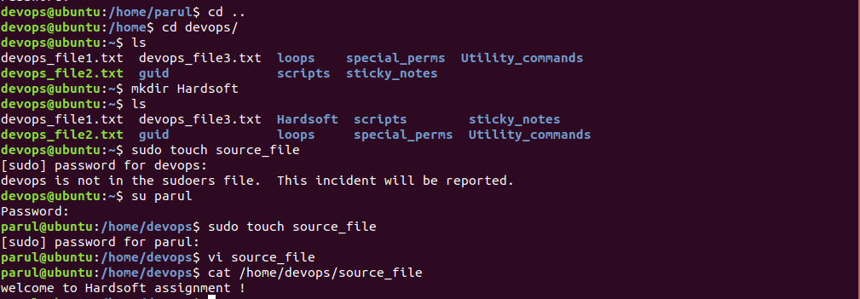

1. Now create a symbolic/soft link to the file



1. Let us now compare the data of both files



1. If we modify the source_file then the softlink file also gets updated.



1. If we delete/remove the source_file, then the softlink file also can’t be viewed.



**Use Case 1:** Create a use case for linking using --arg –backup

When you create a new link, you can instruct command to take a backup of the original file before creating the new link using –backup option

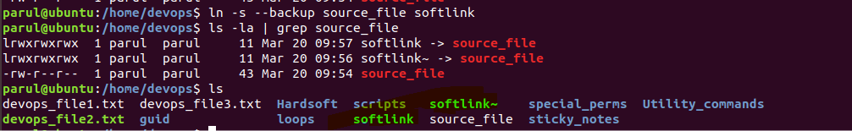

**Use Case 2:** Create a use case for linking using --arg –logical

It allows you, to create a *hard link* of a file where a symbolic link points to. It is used when -s is not in effect and source file is symbolic link.

**Use Case 3:** Create a use case for linking using --arg –Suffix

It is used to override the usual backup suffix

It is used with -s, to create links relative to link location

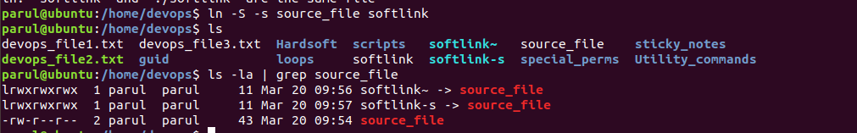

**Use Case 4:** Create a use case for linking using --arg –relative

It is used with -s, to create links relative to link location



**Hard Links**

How do we create Hard link?

1. Create a file called source.file and print its contents



1. Create a hard link to the file and check content of both files.



1. Check I node and permissions of both files



Now remove the original file and see if the file hard link exists or not

